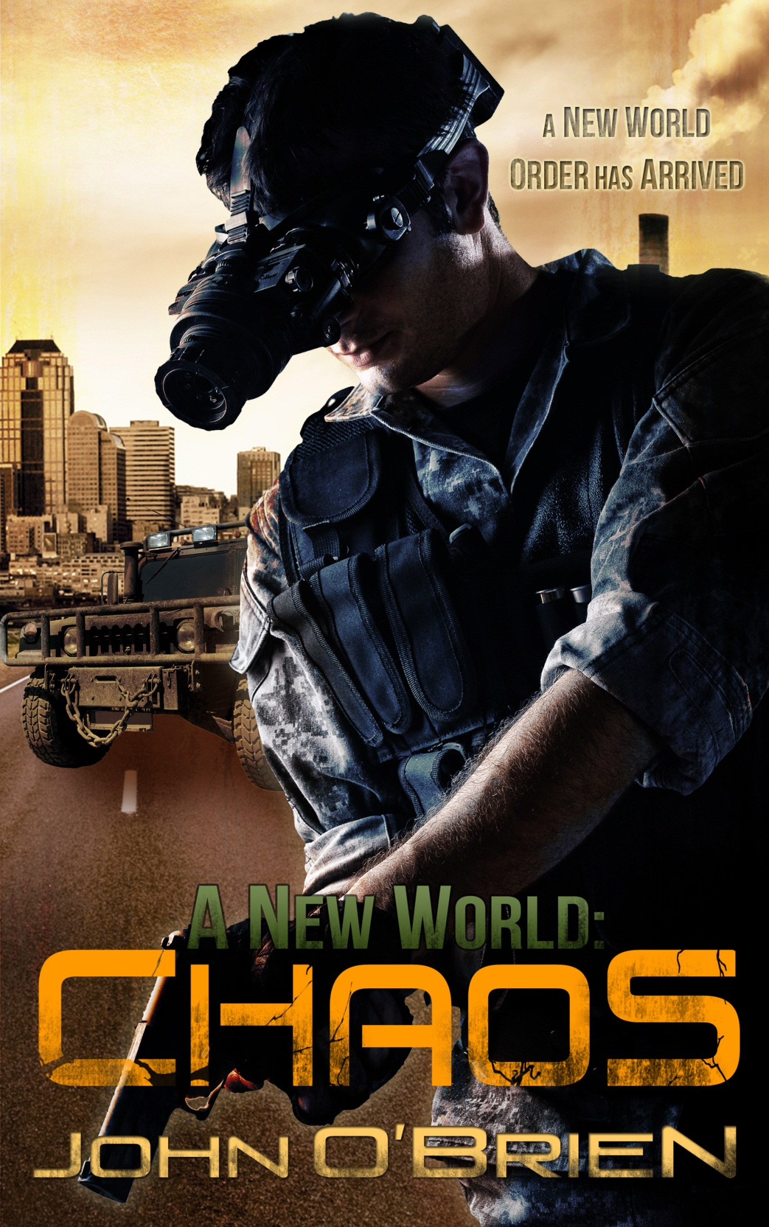
A New World:
Chaos
A Novel by John O’Brien
Copyright © 2010 John O’Brien
All rights reserved. No part of this book may be reproduced in any form, except for the inclusion of brief quotations in review, without permission in writing from the author.
Cover art by: SM Reine
http://smreine.deviantart.com/

This book is dedicated to my wonderful children, William and Heather.
The New World series is a fictional work. While some of the locations in the series describe actual locations, this is intended only to lend an authentic theme. Any resemblance to actual events or persons, living or dead, is purely coincidental.

Also by John O’Brien
A New World Series
A NEW WORLD: CHAOS
A NEW WORLD: RETURN

SAMPLE
The one closest to the door, and hence me, opens its eyes, staring back at me through the light. Rising with lightning speed to its knees, its mouth opens and lets out an ear-blasting shriek of alarm. I pull the trigger and the gunshots join in this sudden escalation of noise, the flash of my rounds giving a quick strobe-like quality to the room and hallway, affecting my vision only slightly. The burst of rounds stitch across its body from the chest upwards, hurling it back into the huddled mass; its scream changes in mid-shriek; from alarm to pain to nothing.
The smell of gunpowder wafts in the hallway as time stands still for a moment. The only sound that of the empty cartridges bouncing metallically on the floor. The stillness ends with an explosion of activity and noise as the things all seem to rise instantly and as one, the shrieks from them deafening as they charge for the door. Two more bursts lift the two in front off their feet and into those behind as the others streak for the door. I am going to have to reload before I can take them all down therefore allowing them to pour into the darkened hallway. With this in mind, I start backing down the hallway toward the stairway focusing on the room’s entrance and thumbing the fire selector to ‘semi.’
The first one appears at the door. My round enters its head just beside the left eye, rocking its head backwards. The back and side of its head explodes outward, coating the doorjamb with blood and bits of bone and gray matter. It falls forward to the ground onto its chest and face, its momentum carrying it forward further into the hallway. A second one appears leaping with a shriek over the body falling in front. Another strobe of light and popping sound of a round leaving the chamber fills the hall. The body is thrown sideways in mid-leap from the round slamming into the side of its chest, cutting the shriek off mid-way. Hitting the floor, it skids across the linoleum, coming to rest against the hallway wall.
Three more enter into the hallway at an almost full run, turning toward me as they exit. Three more rounds fly from my barrel, sending them all to the ground; the one on the right flies backward with its feet over its head, slamming head first into the floor with a meaty smack. By the time the last one has fallen to the ground, five more have poured into the hall and launch themselves toward me. I continue backing toward the stair door with the smell of cordite strong in the air. I fire once at the one closest, bringing its forward momentum to a sudden halt. It just stands there as if its body doesn’t believe it has just been shot in the sternum. Unable to continue forward, it slumps toward its final resting place. A movement brings the next one in line with my barrel as a loud, metallic crash erupts close behind me.
I’m so outta here, I think turning to bolt towards the fire door that stands between me and the stairs. Racing to the door, my light catches the aftermath of the metallic crash. An upended aluminum cart lies on its side at the hallway juncture. Shards of glass on the floor glitters faintly in the light. A beaker rolls in slow circles amidst small metallic shapes scattered about. Three more of the things have rounded the corner running in my direction, the one on the right shrieking loudly. I hear footsteps pounding behind me mixing with those that have now entered the hallway in front of me with more sounding from the hallway around the corner.
I reach the steel fire door at a run, throwing it open and race through it on the fly with those things right on my heels. I can almost feel the warmth from their bodies on my back and hear their breathing seemingly inches away. Launching down the stairs, I keep my light focused on the stairs themselves. This would be the absolute wrong time to trip or stumble. Rounding the corner of the landing and using my hand on the railing to help my turn, one of them enters into my cone of light just ahead on the stairs, having apparently jumped over the railing from the flight of stairs behind me. Too close to bring my M-4 to bear for a shot from the hip, I duck my shoulder and head and slam into its chest knocking it backwards. It flies off the stairs and lands almost to the bottom, close to the second floor landing, hitting the stair with the small of its back, sling-shotting its head backwards to smack into the concrete landing with a sharp, meaty crack. Blood spurts outward from where its head was introduced to the concrete and it slides backward into the concrete brick wall with another, slightly smaller, wet, crack, coming to rest face up. Blood immediately begins pooling outward around its head.
The impact slows my momentum. I feel the brush of a hand against my left shoulder as my feet continue their flight down the stairs, the thing reaching over the stair railing directly beside me. Leaping off the second stair from the landing and over the prone body, I turn quickly in mid-leap facing both the next flight down and the flight I just traversed, thumbing the selector to ‘burst.’ My light flashes to the stairs coming down, my direction reversed. The stairs are completely filled with an ashen gray horde barreling toward me, a few scant feet away.
Just before my feet come into contact with the landing, three rounds exit my M-4 at the nearest one sending it backward into its companions as the steel jacketed rounds pound into its chest and neck, spraying blood outward. I feel a few warm splashes hit my cheek and forehead. Flashes bounce off the concrete brick walls as my feet contact the landing and gunshots echo loudly in the stairwell, overwhelming the growling emitting from the horde. My second burst slams into the next ghoulish thing setting foot on the bottom stair, spinning it to the right and into the arms of the one behind, gaining me another foot of separation. I launch forward, tearing off down the stairs toward the first floor.
I hit the magazine release button before reaching the third stair down. The magazine clatters down the stairs, its sound of metal bouncing on the concrete mixing with the growling right on my heels. Clearing the bottom of the upward flight of stairs, I grab the hand rail with my left hand and vault over to the final flight, concentrating on landing square on a stair. Hitting a stair edge could cause a trip, stumble, or twisted ankle and that is something I can’t afford right now. Several shrieks fill the enclosed space as I land with bent knees and race to the fire door. Reaching into my vest pocket, I withdraw a fresh mag and slam it into the receiver. I hit the door at a dead run, slamming into it with my left shoulder and spin through the opening. Planting my right foot, I shift my momentum toward the emergency room lobby and exit. The first of the many things streaks out of the still opening door before I have taken my second step.
The lobby opens just ahead with the glare of the light outside pouring through the glass doors. I feel something swipe across my back and am jerked backwards slightly, the back of my flight suit in the grasp of a hand for a split second before being released. Fucking A! These things are faster than I am. This may not end well, I think focusing every bit of energy into my legs.
I sweep into the dim grayness of the emergency room lobby, the light growing brighter the closer to the exit I get. Almost across the lobby and to the doors, I slide down to my knees, do a 180 across the linoleum, and face back toward the hallway as I slide to a stop bringing the M-4 to my shoulder. The roar of seemingly a thousand shrieks fills the room. The ghostly outlines of gray faces mill agitatedly at the edge of the radiating light. I fire a burst into the milling crowd, concentrating on one face that is thrust toward me, its mouth open and emitting a loud, shrieking roar, and watch its head explode as it falls backward into the darkness beyond.
“Motherfuckers!!! Come and get some you assholes!” I yell back into the gloom. Adrenaline-rushed fear seems to refocus itself towards anger in me once a situation has stabilized to a certain extent.
I rise to my feet and step toward the darkened hallway, firing another burst into one of the dimly outlined bodies only to watch it too launch backward into the darkness. More popping sounds combine with the roar of the crowd beyond as I continue stepping toward them squeezing off bursts. The cordite smell once again fills the air, mixing with and then overwhelming the previous stench. My barrel makes slight alterations in the air as I focus on one target after another, cartridges clinking as they bounce across the tiled floor. I reach the halfway point in the lobby and a single, unified shriek sounds out. The ghostly faces disappear seemingly as one. The only sounds are growls and pounding footsteps as they run away down the hallway, diminishing in volume as the darkness swallows them up.

